File Permissions in Linux
Project description
The research team in my organization wants to change permissions for certain files in the projects directory. By changing permissions for certain files, the organization can keep its file security by ensuring the least privilege of permissions. To complete this task, I performed the following tasks:

Check file and directory details
The following lines of code show how I determined the existing permissions for each file in a certain directory.
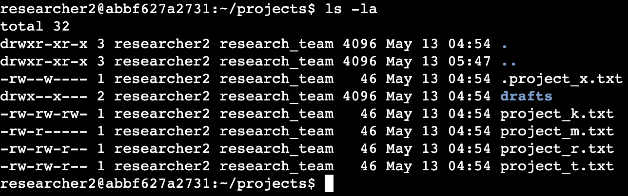
The first line of the screenshot is a line that I used for determining the permissions given for each file in a certain directory. Other lines of code display the output of my command line. The code lists all the files in the projects directory. I used the ls command with the -la option to list all of the files in the directory, including hidden files, with the description of permissions for each file. The output displays that there is a drafts directory, a .project_x.txt hidden file, and four other project files. The 10-character string in the first part of each code represents the permissions given to each file or directory.

Describe the permissions string
The 10-character string demonstrates who is authorized to access the file and their specific permissions. The characters and their representations are described as follows:

- 1st character: This character is either d or a hyphen(-) and indicates the file type. A letter d indicates that the file type is a directory, and a hyphen(-) indicates that the file type is a regular file.
- 2nd-4th character: These characters indicate the read(r), write(w), and execute(x) permissions for the user in order. If there is a hyphen(-) instead, it means that this permission is not granted to the user.
- 5th-7th character: These characters indicate the read(r), write(w), and execute(x) permissions for the group in order. If there is a hyphen(-) instead, it means that this permission is not granted to the group.
- 8th-10th character: These characters indicate the read(r), write(w), and execute(x) permissions for other in order. If there is a hyphen(-) instead, it means that this permission is not granted to others.
For example, the file permission for the file project_t.txt is -rw-rw-r--, which means the user has permissions to read(r) and write(w), the group has permissions to read(r) and write(w), and others have permission only to read(r). No one has execute(x) permission for project_t.txt.

Change file permissions
The organization decided that others should not have permission to write to any files in the directory. To achieve this, I referred to the file permissions that I previously returned. I determined that I should remove all write permissions for others in the file system.
The following code demonstrates how I used Linux commands to achieve my goal:
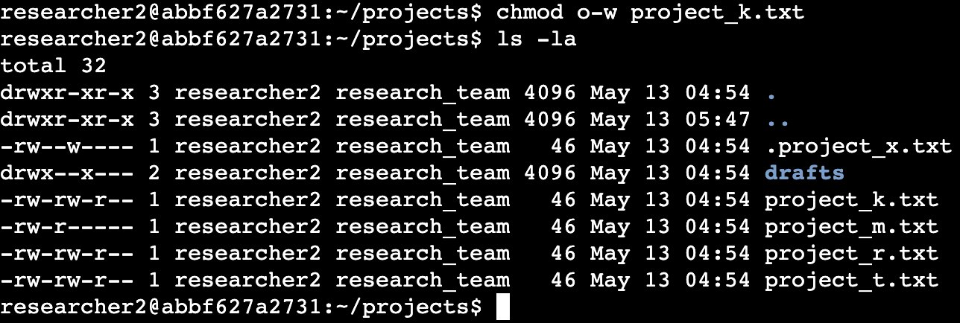
The first two lines show what Linux commands I used to change the permissions for the file. I used the chmod command to remove the write permission for others. The first argument of the chmod command indicates removing writing permissions for others. The second argument of the chmod command designates the file that permission change will occur, in this case, project_k.txt.
Finally, I used the ls -la command to figure out that the change had been successfully updated.
Change file permissions on a hidden file
The research team in my organization recently achieved project_x.txt. They did not want anyone to have write access to this project, but the user and group should have read access.
The following code demonstrates how I used Linux commands to achieve this:
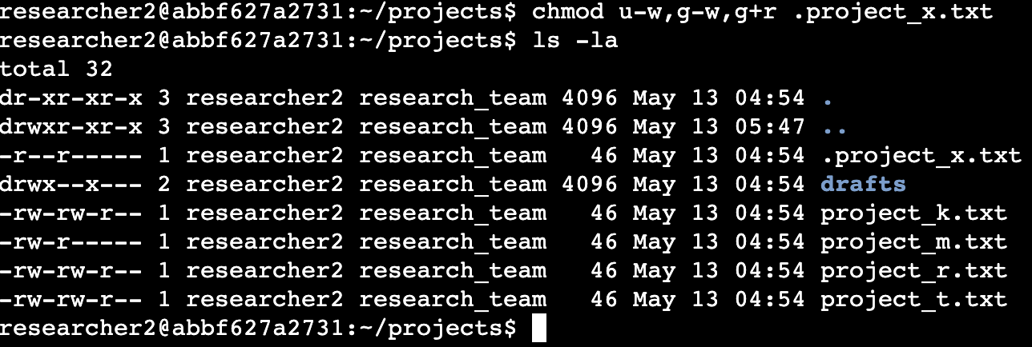
The first two codes show the Linux command I used to achieve my goal. I also used the chmod command to change permissions. According to the first argument of the chmod command, I removed the permission to write for the user and group, and added the permission to read for the group, since the group did not have a reading permission. Then, according to the second argument, I applied these changes to the .project_x.txt file. Finally, I used the ls -la command to check that the changes had been updated correctly.

Change directory permissions
My organization only wants the researcher2 user to have access to the drafts directory and its content. This means that no other individual than researcher2 should have execute permissions.
The following code demonstrates how I used Linux commands to change the permissions:
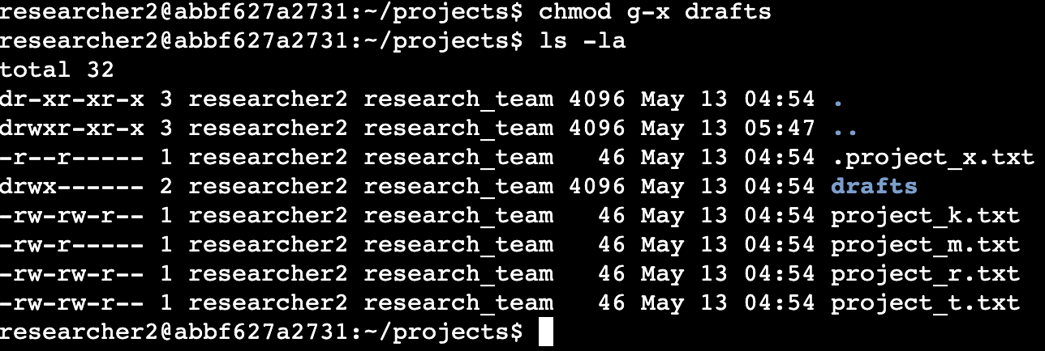

The output here displays the permissions given to each file or directory. You can see that there is a drafts directory on line 4 of the output; only researcher2 has the permission to read, write, and execute. Previously, I determined that the group had an execute(x) permission for the directory, so I used the chmod command to remove this permission. Since the researcher2 user already has an execute(x) permission, there is no need to be added.

Summary
I applied multiple changes to match the level of authorization that my organization wanted for files and directories. The first step was using the ls -la command to check the existing permissions for each file or directory. Then, I used the chmod command to add or remove the permissions on certain files and directories to follow my organization’s needs.

What I have learned
- Using the ls -la Linux command to check permissions for a certain file or directory
- Using the chmod Linux command to apply certain changes to a file or directory

